## Overview

You are going to create several documents needed for an upcoming seminar on Microsoft Office (Word, Excel and PowerPoint) that will be held at Las Positas College. You will be using Microsoft Office Word, Excel and PowerPoint. You will create a budget for the seminar in Excel, use Word to create a flyer to announce the seminar, and create a PowerPoint presentation about the features of Microsoft Office features that you believe increase productivity.

**Excel**

1. Launch Microsoft Office Excel 2016
2. 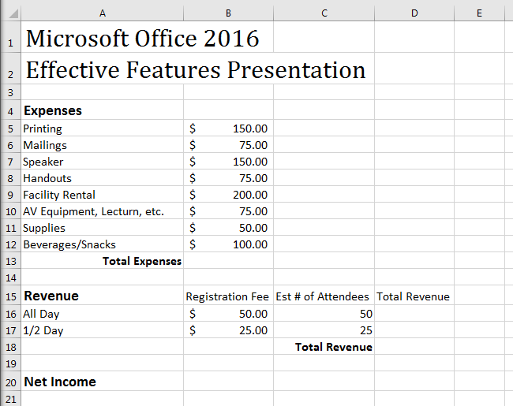Create the worksheet shown below:  
   *Note: Your font style and size need not exactly match this worksheet, but relative size of the elements, bold, number formats, and cell alignment should be applied. For example, the title should be larger, and section headings should be bold.*
3. In cell B13, create a formula that calculates the total of all expenses.
4. In cell D16, create a formula that calculates the revenue that will be generated by the participants who will attend the full day (Registration Fee for All Day * Est # of Attendees)  
   *Hint: remember, all formulas in Excel must begin with* **=**
5. Copy the formula created in cell D16 to cell D17
6. In cell D18, create a formula that calculates the total revenue for full day and half day attendees
7. In cell B20, create a formula that calculates the Net Income (Total Revenue – Total Expenses)
8. Print Preview your worksheet. Adjust column widths, if needed, so that no information is cut off.
9. Save using the file name **Seminar Budget xx**, but replace **xx** with your initials in the file name.
10. You will submit this file in Canvas once you have completed the entire project.
11. Close Excel.

## **Word**

1. Download **Seminar Flyer.docx** (as shown below) from Canvas to your computer.
2. Launch Microsoft Office Word 2016
3. You will create a flyer inviting people to a presentation. Format the invitation as shown.
4. 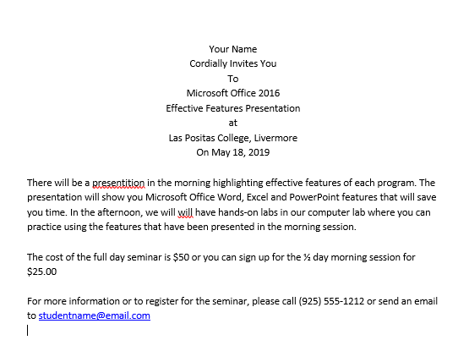Correct spelling and other errors. Feel free to change the fonts and /or font color and add images.

Seminar Flyer.docx - Starting File

1. Use Save As to name the file **Final Seminar Flyer xx**, replacing **xx** with your initials in the file name.
2. Print preview the flyer, make any corrections (spelling, grammar, etc.) or any other changes to make the flyer visually appealing, then print is to PDF (or save as a pdf, depending on your version) to turn in on Canvas.
3. Close Word.

## **PowerPoint**

1. Launch Microsoft PowerPoint 2016
2. You will be creating a presentation on Microsoft Office 2016 Features
3. Pick a design theme of your choice.
4. On the Title Slide, add the title **Effective Features: Word, Excel, & PowerPoint** to your presentation,   
   and enter your name as the subtitle.
5. Add a Title and Content slide with **Topics**  as the title, and list the topics you will be presenting:

* Word Features
* Excel Features
* PowerPoint Features

1. Add another Title and Content slide. Add the title **Word Features** and list three to six things you learned or liked about Word as bullet points.
2. Add another Title and Content slide. Add the title **Excel Features** and list three to six things you learned or liked about Excel
3. Add another Title and Content slide. Add the title **PowerPoint Features** and list three to six things you learned or liked about PowerPoint.
4. Add a Title Only slide with the title **Thank You**
5. Save using the file name **Microsoft Office Presentation xx**, replacing **xx** with your initials.
6. Click on the Title Slide in the slide thumbnails pane, then print preview the presentationas a handout with **4 slides Horizontal** in **Landscape** orientation.   
   *Hint: Use File-> Print, then click Full Page Slides under Settings to get to the handout options.*
7. Take a screen shot of page 1 of the handout (4 slides), then return to the Home tab and add a slide with the Blank layout to the end of your presentation. Paste your screenshot on this slide. Save your changes. This is your final file to submit for the Applications assignment.

